An XVIII Dynasty Dance

That autumn afternoon in 1986 it was cold. Winter was on its way and the British Museum was almost empty. I was on my way to the Ancient Greek rooms on the first floor which meant I had to pass through the Egyptian gallery on the ground floor with its monumental statues of gods and pharaohs. Strange as it may seem now I have never and still no interested in Egyptian history and yet there was one exhibit that I could always find the time to stop and adore.
The exhibit is a fragment of plaster roughly the size of a suitcase and in 1986 it was being displayed in a mock-up of an Egyptian tomb. On stepping inside one turned left into a narrow passage, squeezed past a monkey god on a plinth, and there at the end of the passage were three or four plaster fragments from the Theban tomb of a young scribe named Nebamun. One of those fragments depicted a banqueting scene set in heaven.

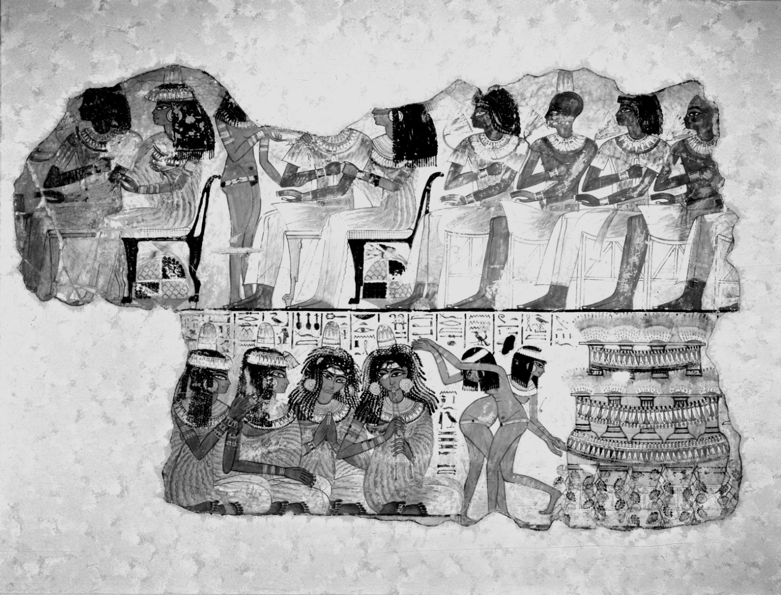

I fell in love with this painting when I was a schoolboy and over the years my admiration for the artist has grown with every visit. Not only was the man a great technician he also had a wicked sense of humour. Look at the dancer in the foreground. Her hands are under the hieroglyphs for hands. Then see where the dancer in the background has her rear end, the two hieroglyphs onto which she is backing represent the word back or behind.
Nebamun’s tomb must have been incredibly beautiful and its loss is testament to how much irreplaceable art, time and looting have destroyed.
The label associated with this painting told how the young women were gyrating to the music. I must have stopped to look at this painting twenty or thirty times and always took it for granted that the young women were indeed gyrating, however on this particular afternoon I noticed something I had never seen before. The dancer in the foreground has crossed her arms and entwined her fingers. That was not gyrating. It was such an awkward pose for her that she must have known she was going to cross her arms before she began to dance. Thus the dance was choreographed!

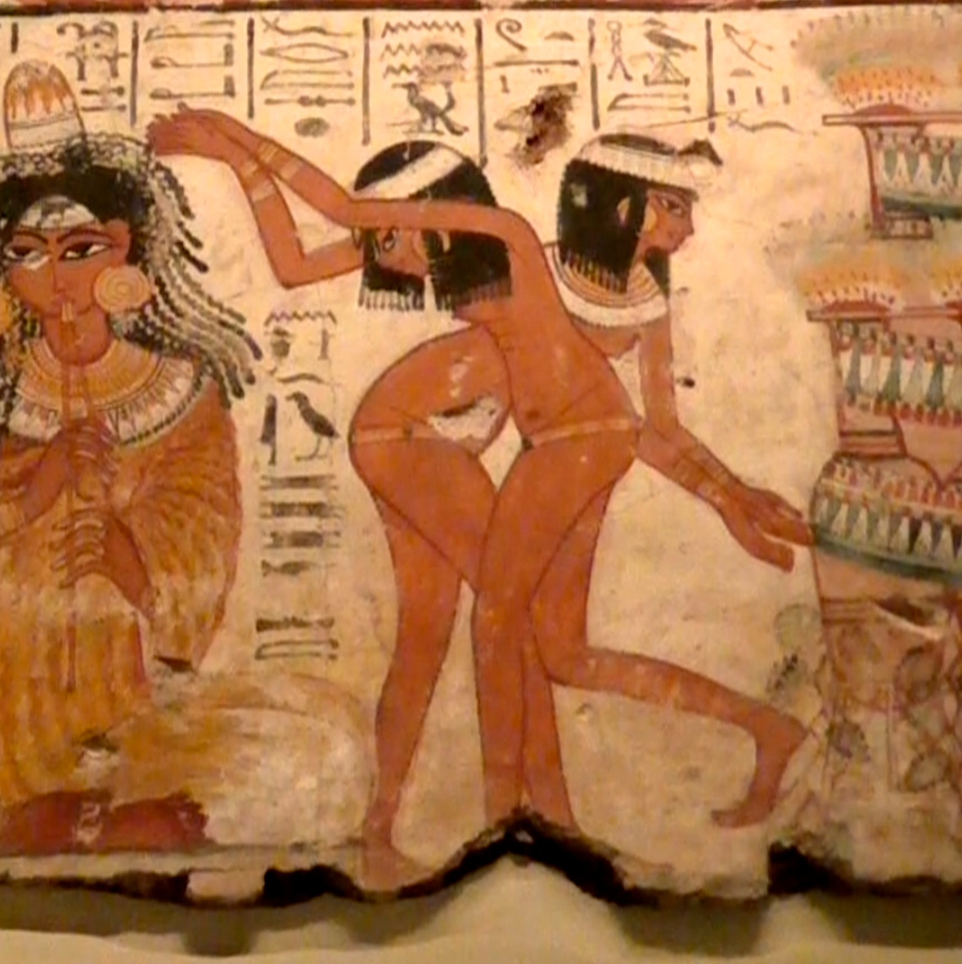

The position of her arms was the key to unlocking the painting and suddenly it began to reveal its secrets. I suspected the women were miming so I obtained a translation of the hieroglyphs above their heads and sure enough they were. It was the song the musicians were singing. But the woman in the foreground is miming to the first line, while her companion behind is miming to the second line. So the two dancers were in different time frames. That is an artistic trick meant to give the illusion of movement. There are not two women but one woman turning from line one to line two. But this illusion doesn’t work for us. We see two dancers. It only works if the audience knows the order of mimes. So this young woman had to be miming to a popular song, using mimes that were understood by everyone.
Now, the beauty of a mimed dance is that it can be recreated. However, when the painting was hacked from the wall of Nebamun’s tomb the looters only managed to save the first part of the song. Here below is a translation of that portion and for the sake of clarity I have added line numbers, though the lines only become apparent when the song is complete. So this is cheating, but helpful.

1 (..........) fragrances given by
2 Ptah and planted by Geb.
3 His beauty is in everything.
4 Ptah did this with his hands
5 to satisfy his heart. Water returns to the pools
6 as the land appears; watered
7a by his love...

I now needed the rest of the song, but after three thousand years I think it is safe to say no reasonably sane person would ever expect to find it and yet, idiot that I was, I started looking. I looked everywhere, but after two weeks had found nothing. However, on the day I decided it was never going to find it, I was standing in Watkins bookshop, just off the Charing Cross Road. During my search I had discovered a fascinating treasure trove of ancient Egyptian literature. So before leaving the shop I decided to console myself with an anthology, which I began to read on the train home.
The book really was an Aladdin’s Cave. As I flicked through its pages I found one amazing story after another. Some were morality tales, others were historical, a history I had never imagined. Then in the final section there were poems and among them was The Ferryman’s Song.
For some reason I could never fathom, the experts always get this translation wrong and have the Ferryman standing in the back of his boat with a bundle of reeds on his shoulder, which makes no sense. So this is my translation and once again I have added line numbers to the relevant portion.

I am drifting downstream by the stern of the ferry.
Behold, poling because of the reeds.
My reed pole is on my shoulder.
I am returning to Ankh-towy
I am returning to speak to Ptah, Lord Truth,
urging, “Give to me a sister to have this night.”
7b ......................... The sea its water, lo it is wine!
8 Ptah he is its reeds
9 Sekhmet its (........)
10 Iadet its buds
11 Nefertem he is its lotus
12 (..........) who is joyful
13 brightens land with her beauty. Mem-
14 -phis is a jar of wine
15 set before of the
16 beautiful face.

To say my eyes almost popped out of my head is an understatement. It was a miracle. I could hardly believe what I was looking at. After all that fruitless searching I had stumbled on the missing portion by accident!
The song comes an ancient anthology, a collection of songs and stories known as the Papyrus Harris 500, a papyrus that, ironically, is held by the British Museum.
Now, the first portion of the Ferryman’s Song is cheeky, the word sister is a euphemism for prostitute, but not terribly good poetry and too short to stand on its own. So the composer, let’s call him the Ferryman, removed the first seven lines from a song that he had heard while in Thebes (the same seven lines in the Nebamun painting) and added his own. No doubt the chap who later compiled the Papyrus Harris 500 had heard the song being sung along the waterfront and thought it was worth keeping. But in recording that bastardised version he inadvertently preserved the missing lines from the Nebamun Song.
Now came the difficult part. How was I going to prove the Nebamun Song, let’s call it the A portion, belonged to B, the lower portion of the Ferryman’s Song?
The fact that it was glaringly obvious the two portions belonged together was not enough. I needed concrete proof. It seemed a monumental task and yet the answer was staring me in the face.
Whereas traditional English rhyming poetry tends to rhyme on the last word of each line or alternate lines, Egyptian poetry rhymed internally. Thus a particular syllable would appear halfway along line one and then that same syllable would reappear halfway along line two which had the effect of creating columns of sound that descended through the poem. That meant I should see columns of sound descending through A, crossing the join, and continuing through B. The columns would in effect act as a fingerprint.
What now needed was a transliteration of both portions, that is, the actual sounds that the hieroglyphs represented and below are the hieroglyphs in the Nebamun painting. Please excuse my clumsiness attempt. I’m no scribe.

Unfortunately the first column on the left is missing, though that is only a temporary inconvenience as it is easily repaired. And this is the transliteration.

And this next is the complete Ferryman’s Song from the Papyrus Harris 500. The original is written in hieratic which, to my great relief, was transcribed into hieroglyphs by W. H. Muller in his book Die Liebespoesie der Alten Agypter, Leipzig 1899, p.4-5, lines 5-9. I must thank the University of London for allowing me to use their library for this. I made this copy thirty-five years ago and the book was fragile then.

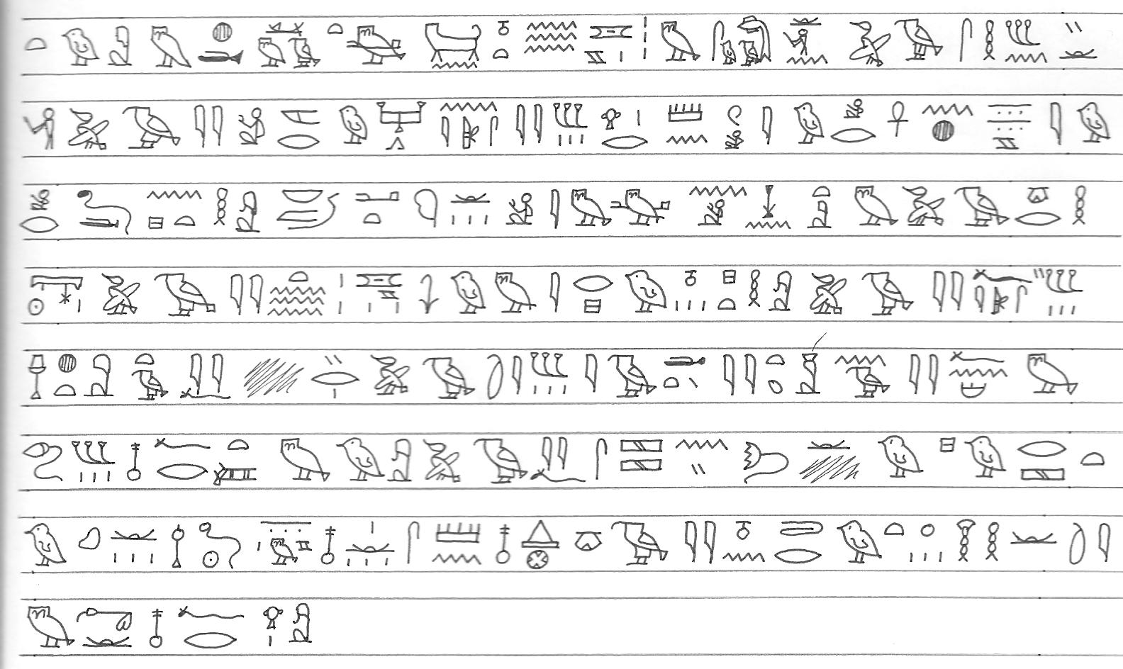

I cannot see any point in transliterating the portion added by the Ferryman so this is portion B.
Breaking down the words into syllables was not easy. The script is missing several vowels and as it is a dead language no one knows which vowels are missing and where. The problem is further complicated by the likelihood that the Theban dialect was probably unintelligible as far north as Memphis. The north was always very cosmopolitan with a continual influx from Arabia whereas the south was very African. In fact I imagine the dancer in the Nebamun painting and perhaps the musicians as well were either Nubian or Nubian by descent.
Despite these problems the table is my attempt breaking down the two portions into syllables. The dotted line indicates the join between A and B.

As it is at present the only column which can clearly be seen to cross the join is D, though there are others. However, if we omit line 16 then an alternating sequence appears in column A. Beginning at line 13 it carries on round to lines 1 to 4.

13 14 15 1 2 3 4
w nf wt … pth nf pth

That alternating sequence shows the song was a loop; that it was meant to be sung repeatedly, over and over again. Line 16 mirrors line 1 and must have been a concluding line that brought the song to an end. So the missing word at the beginning of line 1 has to be nfrw, beautiful. Adding that to the table completes the alternating sequence in column A.

13 14 15 1 2 3 4
w nf wt nf pth nf pth

The table below the repair at A1, the columns of descending syllables crossing the join, and the rotation with the concluding line 16. I suspect column E should be one continuous column and that the singer laid particular stress on that column. Also, I suspect the dancer completed her mime at that precise moment.

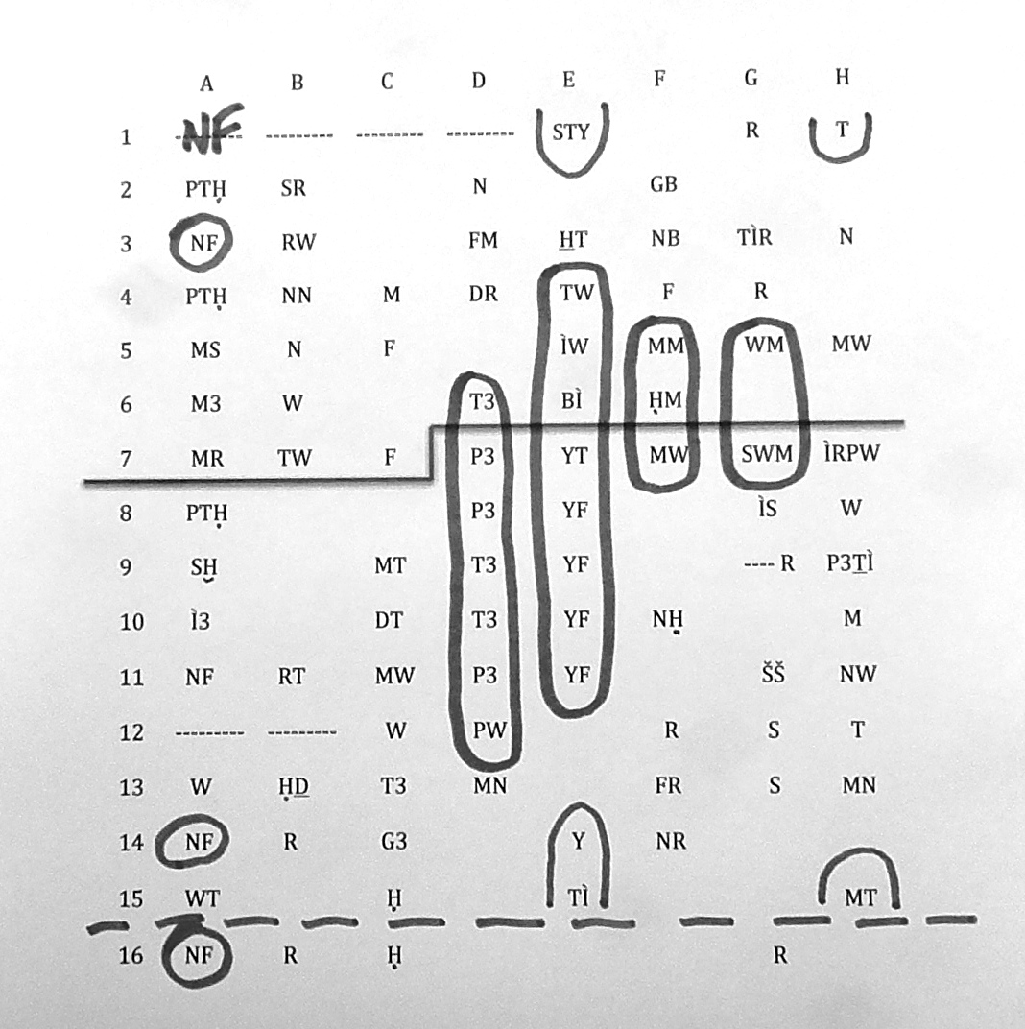

Because of the repetitive nature of this poem it allows me to replace missing words and so below is the completed table.

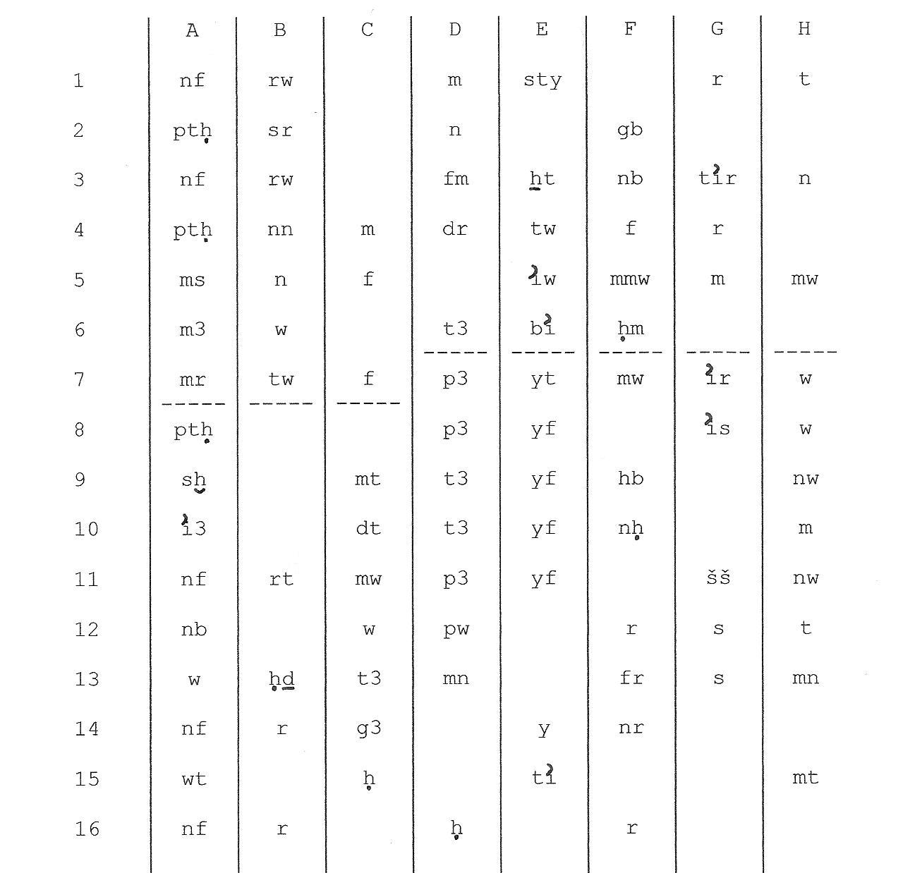

The completed table recreates the original song, which I think you will all agree is an absolutely beautiful poem. The man or woman who wrote this song really was in love with the land. It doesn’t happen now, but in ancient times the River Nile would flood and cover the land in a rich, deep red-ish silt washed down to the Nile by the rains falling on the mountains of Ethiopia. That silt made the flood a blessing and produced two crops every year.

1 Beautiful are the fragrances given by
2 Ptah and planted by Geb.
3 His beauty is in everything.
4 Ptah did this with his hands
5 to satisfy his heart. Water returns to the pools
6 as the south land appears
7 by his love. The sea is wine;
8 Ptah is its reeds;
9 Sekhmet its ebony trees;
10 Iadet its buds;
11 Nefertem is its lotus flowers.
12 The Golden One is happy.
13 The land brightens with her beauty. The offering
14 is beautiful; an offering of dance
15 performed for you of
16 the Beautiful Face.

Now that I had the completed song I could begin to think about the mime dance. In the Nebamun painting the dancer was performing her first mime to line one and her second mime to line two which implied one mime to each line. Therefore a total of16 mimes.
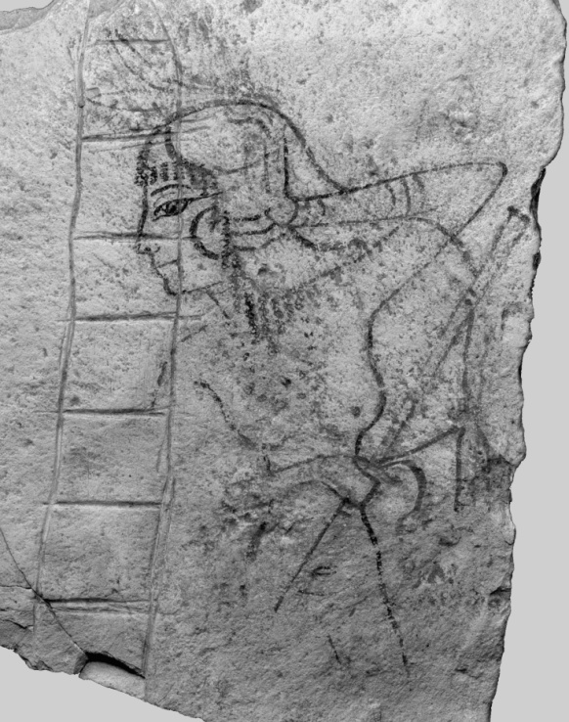
I wish I could say I struggled on with just my brilliance to guide me, but the truth is it was easy and took no more than a couple of weeks. Look at this fragment of pottery in the Berlin, Staatliche Museen of a young woman with a slightly cupped hand beside her face. The accompanying label tells the visitor she has put down her flute so as to sing, but that is wrong. There is another example of this mime in the Cairo Museum and is only ever performed by women. It means I am beautiful, and is the mime for line 14.
To check that I am correct, compare it to this illustration from the book The Tomb of Antefoker by N. deGaris Davies, 1920. This woman really is singing and has placed her hand in front of her ear as singers still do today. None the less it is easy to confuse the two, as we shall see later.

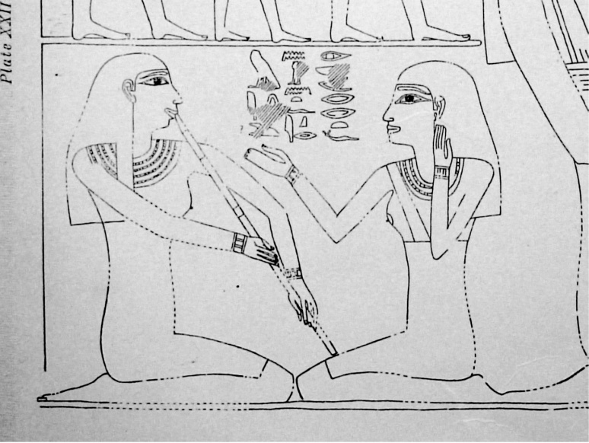
And so the list of mimes grew. However, there was a problem. Matching Egyptian mimes to an Egyptian song was easy, but that doesn’t make it an authentic Egyptian dance because I wouldn’t know if the dancer chose those exact mimes. Line 7, for example, contains the words love and wine. Which mime did the dancer choose?
This was a problem I was struggling with when I came across the tomb of Ibi the priest.
After the collapse of the New Kingdom in the eleventh century BC, Egypt went into a period of decline that lasted over three hundred years. With lower than average rain falling on the mountains of Ethiopia, flood levels in Egypt were down, low floods meant the fields were not properly fertilised, people starved and the economy collapsed. However, with the arrival of the XXVI Dynasty in 664 BC there was a brief period of revival. Nothing was ever going to bring back the age of Ramses II, but at least Egypt was a sovereign kingdom ruled over by Egyptian pharaohs.
When I was a boy in the early 1950’s the British Empire had only recently passed into history and yet people still had an empire mentality. I read somewhere that the general public is always a generation behind the politicians. I’m not sure I could accept that, though I must admit it was certainly true then. So when Ibi commissioned his tomb he wanted all the bells, whistles and flags that came with empire.
Now, the chap who painted Ibi’s tomb almost certainly refined his artistic skills by copying the paintings in the hundreds of looted tombs around Thebes. No doubt he could read the hieroglyphs, yet he knew nothing about the Nebamun dance even though he had probably entered the tomb because when he painted the walls of Ibi’s tomb he depicted women performing mimes from that dance.
The illustration below is from Ibi’s tomb. These women are actually supposed to be dancing and yet they are as stiff as robots. Three hundred years of decline have robbed Egypt of much of her cultural heritage.

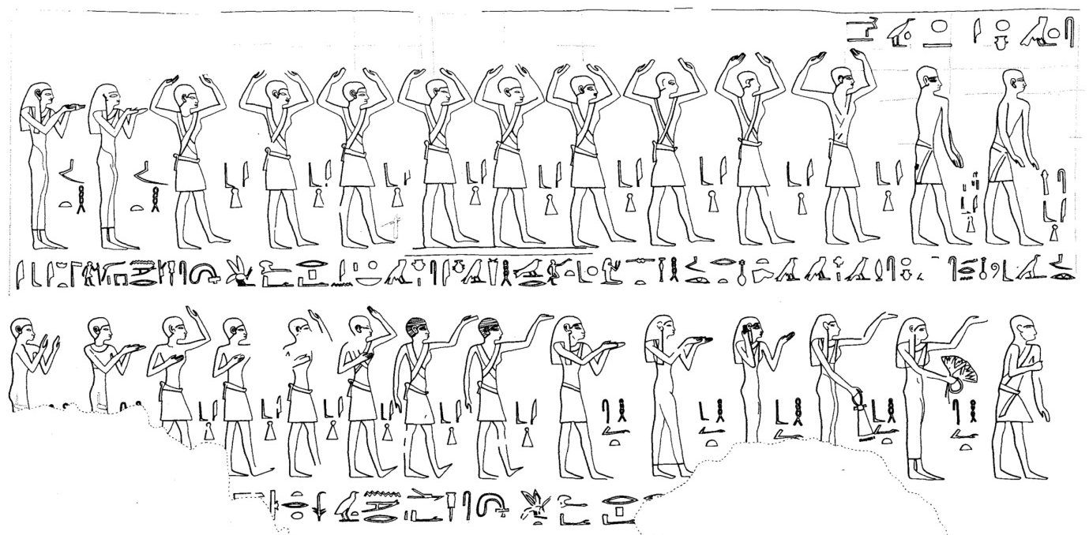
Struggling to live in the past is unique to the human condition. None the less from that jumble of images in Ibi’s tomb comes this sequence of mimes. Look at the dancer performing mime 14. It should be beautiful, but instead of cupping her hand forward it is turned around in the mime to sing.

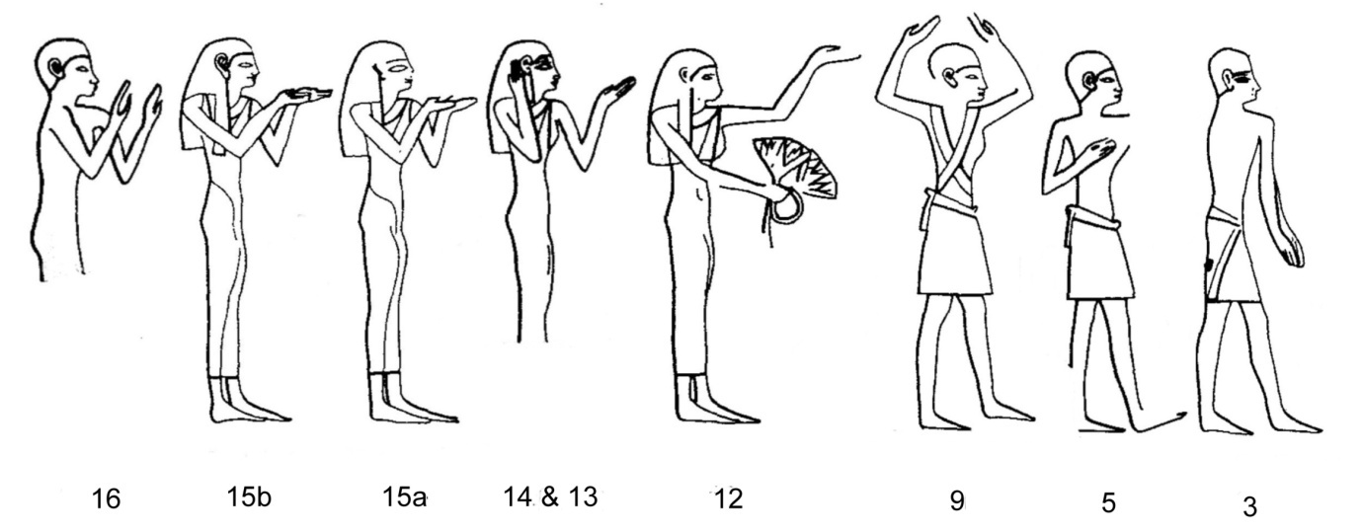

Another inaccuracy occurs at mime 12. The dancer should have both arms in the air for happy, but the artist has given her a bunch of lotus flowers to hold, symbols of the resurrection.
Mimes 15a and 15b look almost identical, but the woman is extending her hands in an offering gesture.
Mime 3 was a mime which no self respecting pharaoh could ever have left out of his repertoire. It meant everything and in the illustration below is being performed by the Old Kingdom monarch Senusret III. Note the size of his ears. Together with the mime he is telling us I can hear everything you say.
Senusret is remembered as a very efficient pharaoh, but being able to read his mime tells us a very different story. The man must have been as paranoid as Stalin. He thought his statues could actually over hear conversations. That meant his suspicions were not paranoia. His statue must have heard something. Just imagine being invited to his palace as a guest. You would almost certainly never be heard from again.

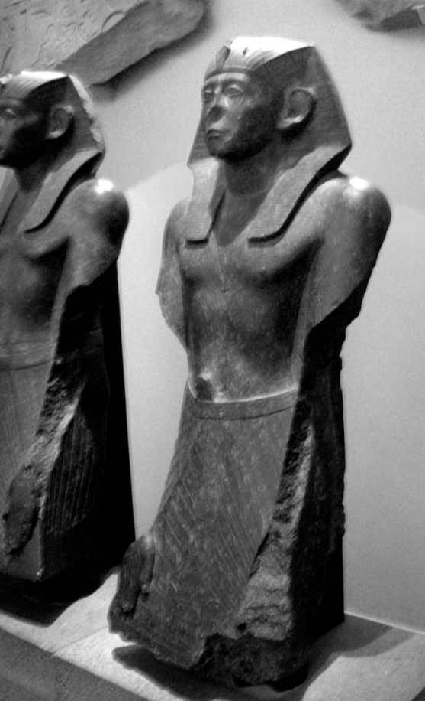

This next illustration is really comical. It comes from Kerasher’s Book of the Dead, a papyrus roll in the British Museum and shows the little man arriving at the hall of the gods just as his heart is about to be weighed in the balance. He enters from the right full of fake confidence with his arms aloft in mime 12 to tell the gods I am happy. Then he walks to the scales where the weight is in the shape of Ma’at, truth. To this he mimes everything. He has told the whole truth. He has nothing to hide. Let’s hope they believed him.

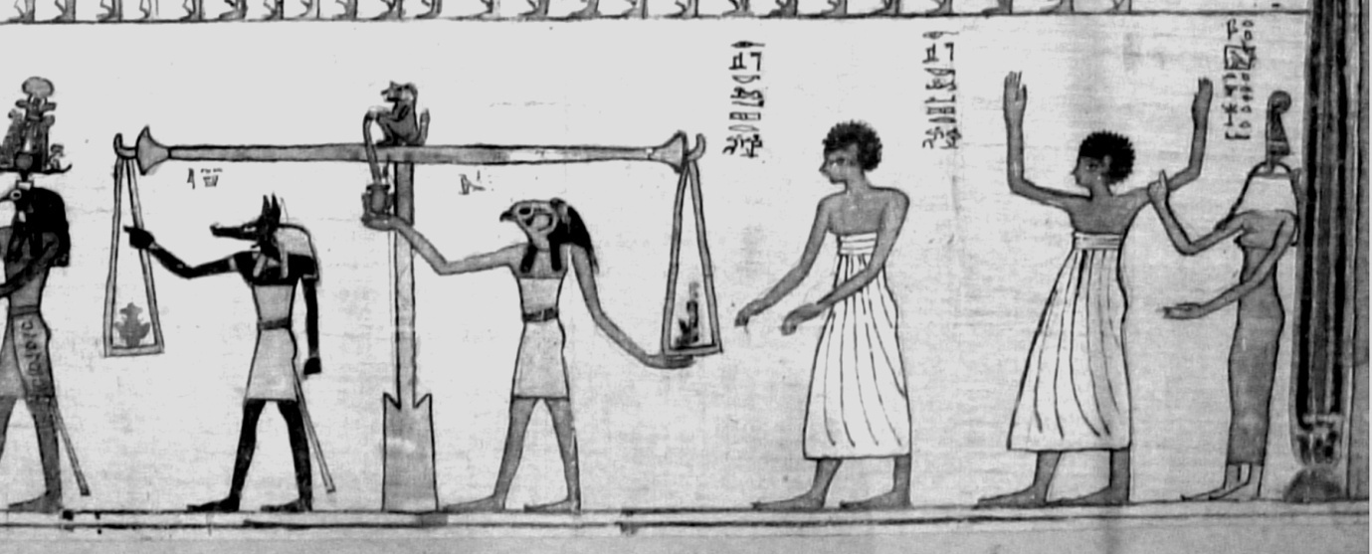

As we have been dealing with royalty there is a mime that, though it has nothing to do with the dance, is so beautiful I really want you to see it. Unfortunately the image is rather poor quality but it shows a young girl dancing with a group of female musicians. It comes from the Theban tomb of Amenhotep-Si-Se and shows the child holding her hands in a very awkward position. The hands are being held back to back, but not touching, and slightly cupped.
Now the mime for baby is an upright finger touching the lips. You will often find Horus in that pose. So this mime could possibly mean child. But I think it means innocent.
This next illustration is from the mortuary temple of Ramses III at Medinat Habu where we see Queen Merytenmut performing the same mime.

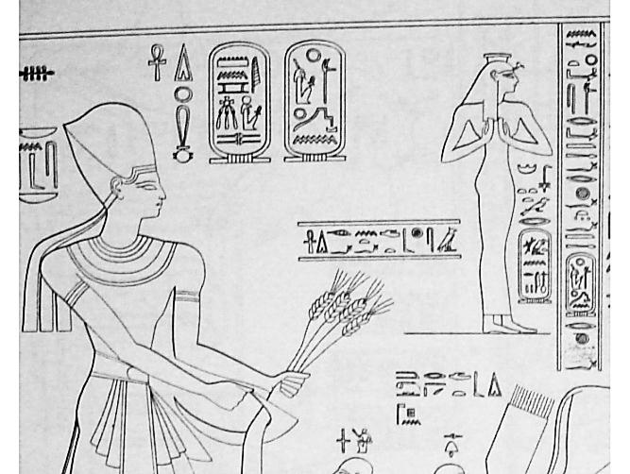
This is the Min festival and Ramses is performing some sort of annual phallic rite. Perhaps the queen was the furrow he ploughed? Looking behind the scene I can’t help but wonder if perhaps she was guilty or accused of some great crime and so had herself depicted as being forever innocent. It suggests life in the royal harem was fraught with danger and intrigue.

This next illustration shows how mimes not depicted ideas but could be magical as well. This is mime 7, wide, and is an illustration by Jean-François Champollion of a scene from the Temple of Isis at Hermonthis. Unfortunately that temple no longer exists. I think it was used to build a cement factory! None the less, here Isis is giving birth to Horus. Look at the mime being performed by the nurse. With her arms wide apart she is magically widening the birth canal to ease the pain.

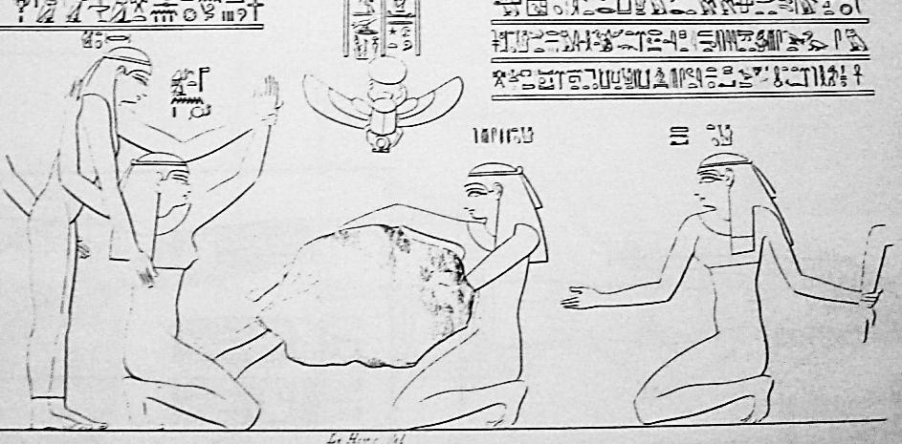
In the Westcar papyrus there is a scene in which Reddedet, wife of the priest of Re of Sakhebu, is about to give birth. To aid in the delivery we are told Isis placed herself in front of her, and Nephthys behind her, and Kheqet hastened the birth. So the woman performing the mime must be the Kheqet Nurse whose role was to ease and hasten the birth by magic.
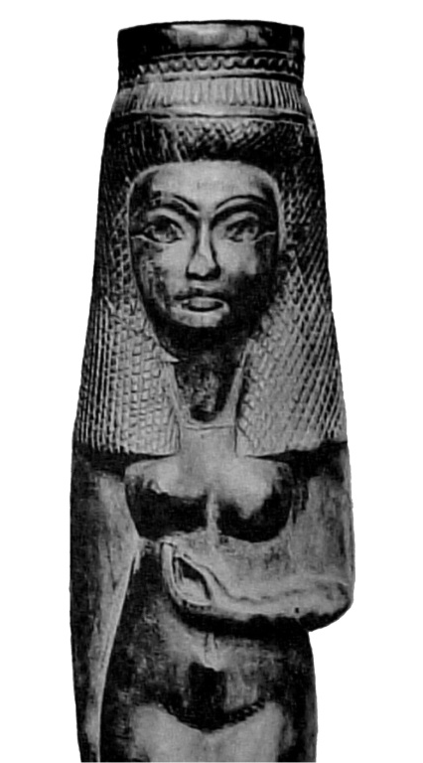
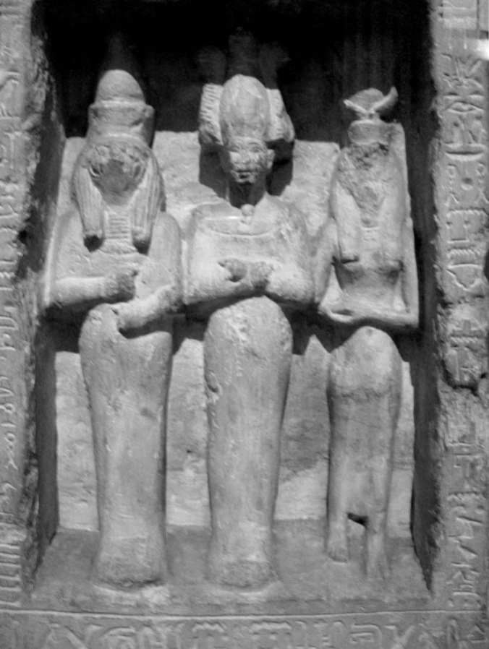
As I said at the beginning, I found almost all of the mimes in the first couple of weeks. However, there was one mime that no matter how hard I searched I just could not find. That was mime 10, lotus bud. Then one morning, some twenty years later, I was flicking through the books in the library of the Egypt Exploration Society when I came across this little lady and there was the mime.
The lady is in the Cairo Museum and is thought to have been the handle of a mirror. However, proof of her mime belongs to the handle of yet another mirror, exhibit 1859 in the Museo di Bologna in which a young woman is making this mime and has a small bird perched on her thumb; the word bird, nhmỉ, is a pun on the word bud, nhm.
This illustration shows a box of divine images, Horus, Osiris, and Isis, being presented by Panehsy, Overseer of the Treasury. Isis is making the bud mime to make sure or to reassure Panehsy that he has a bright future ahead of him.

I don’t think any point would be served in proving every mime as they are so easy to find that anyone could do it in an afternoon. So I shall skip the rest and go straight to the dance itself.
I have to thank my daughter, Suraiya, for posing for me. At the time these photos were taken she was young, free, and single and teaching at Deer Park School in Texas and despite her embarrassment agreed to perform the dance. A lot of water has flowed under the bridge since then.

The dance would have begun with the dancer saluting Nebamun. It wasn’t actually part of the dance proper though it is performed at line 16, and thus is the concluding mime.

Suraiya should be facing the other direction for the mime that follows and, of course, she should be far more humble than she is here. Please excuse my crude sketch, but it’s worth a thousand words.

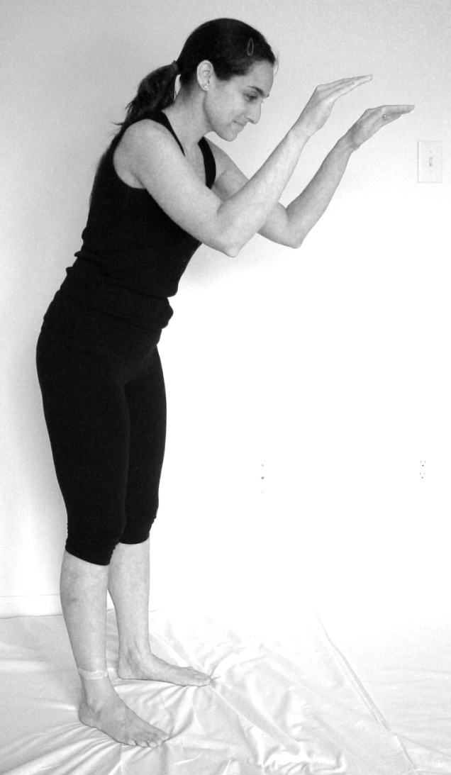

The salutation then morphs seamlessly into mime 1, lotus offering, as the dance begins.
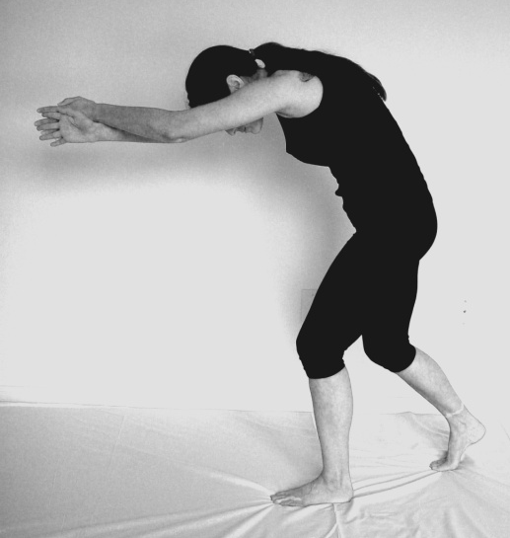

Then she turns, bending down for mime 2 to plant.

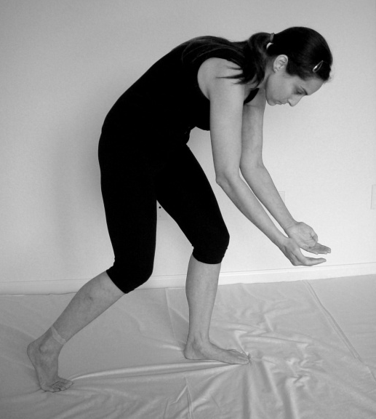

Mime 3, everything.
Performed to the line his beauty is in everything.

Mime 4, to make.
Performed to the line Ptah did this with his hands.

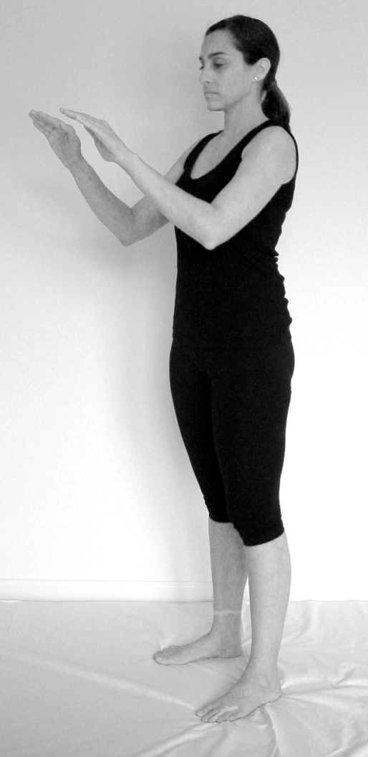

Mime 5, heart
This is a mime often see Muslims greeting each with a welcome followed a hand over the heart. The same was probably true in ancient Egypt, though with greater mystical significance.

It is thought the salutation gesture evolved from a symbolic shielding of the eyes from the glare of the sun, but I don’t think so. Sometimes the gesture looks as if the person is showing his palms, as if the god was meant to read his lifelines, This is my life.
If I am on the right track then this mime had enormous religious, mystical and emotional significance.

Mime 6, pouring Liquid

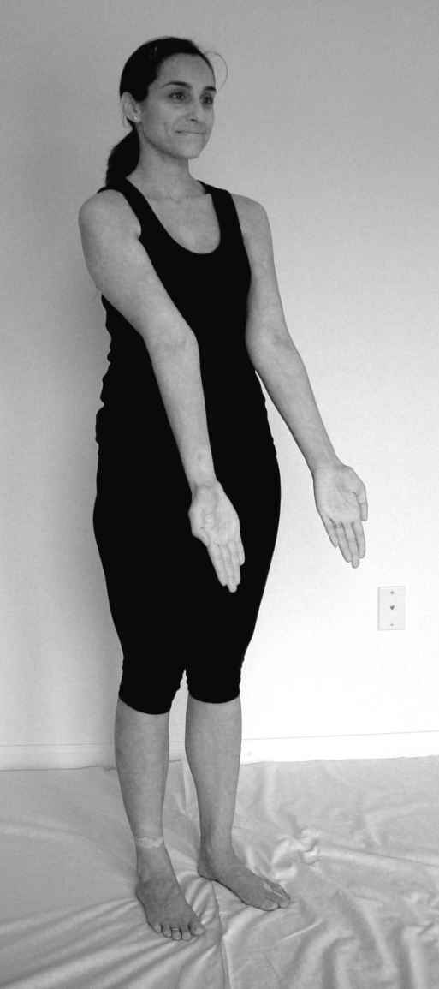
Note the similarity of this to Mime 3, though here the palms are turned up as water pours from them.

Note also that this mime spans one full line and two half lines:

5 ………………….Water returns to the pools
6 as the south land appears
7 by his love………………….

This may indicate the mime was more animated than it appears here. Perhaps the dancer moved her hands as if they were water or the water filling.

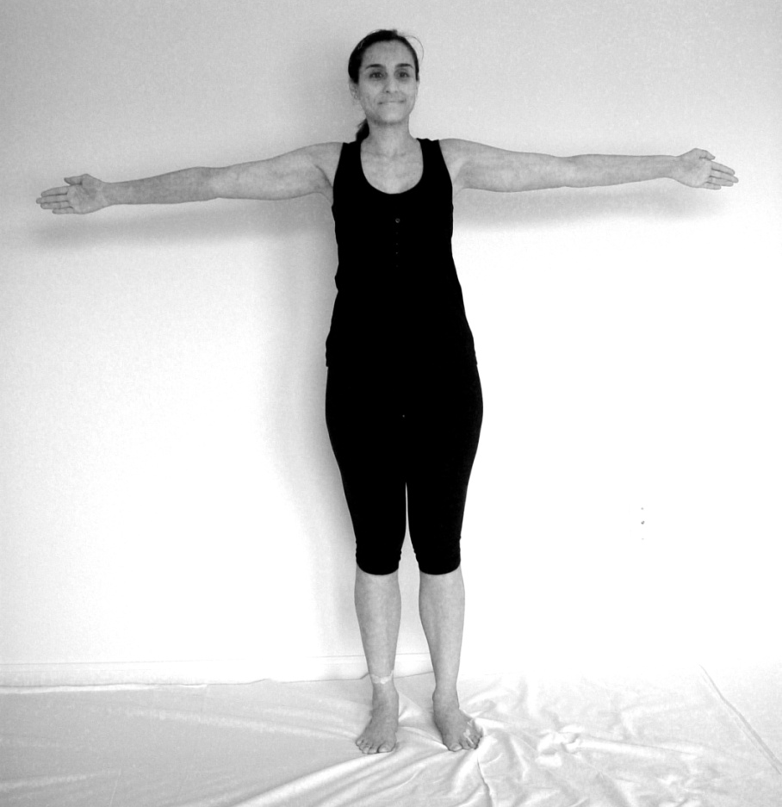
Mime 7, wide.

Performed to the line
The sea is wine…

Mime 8, reeds

This mime begins a beautiful sequence in which a pantheon of deities are called upon as the dancer perhaps descends to the floor.

Ptah is its reeds;

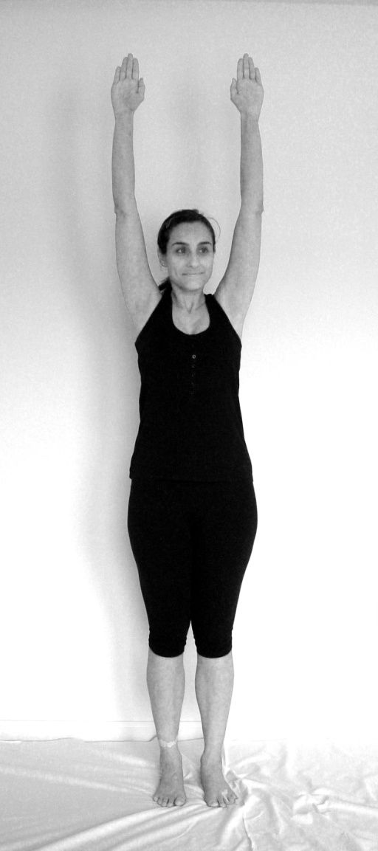

Mime 9, trees.

Note the dancers palms are turned up so once again the gods can see her lifelines.

Mime 10, buds.

To the line, Iadet its buds . . .

Iadet was the goddess of the morning dew, though her name meant scent.

Mime 11, the lotus flower.
Performed to Nefertem its lotus. . .
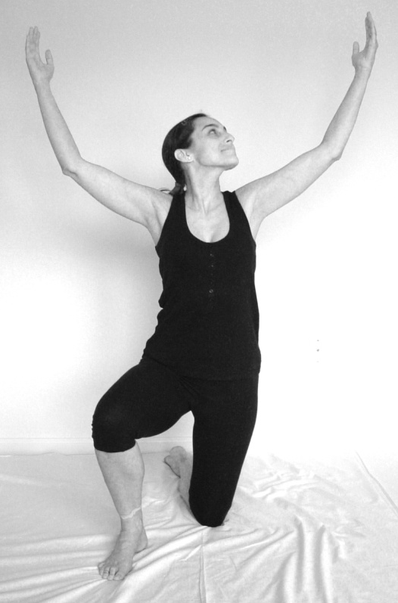

Mime 12, joy.

I think at this point the song may have picked up the pace a little as this line refers to the cow goddess Hathor and she is in a good mood.

The Golden One is Happy.

Mime 13, dawn & 14 beauty.

For this line the dancer has to perform two mimes; dawn as she raises the sun with her left hand; and beauty with her right.

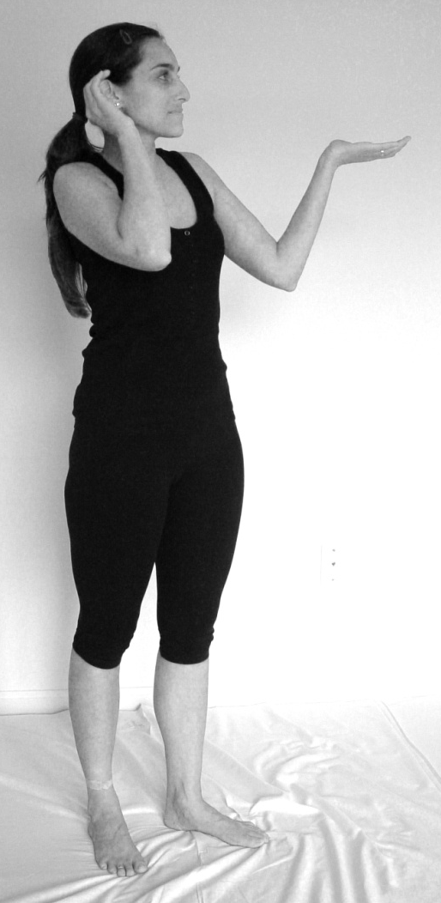

Mime 15a Mime 15b
an offering

This mime begins with cupped hands close to the chest, which are then extended. As the song rotated from line 15 back to line 1 so the dancer extended her arms into the lotus offering mime.

Mime 16, salutation.

And so to the concluding mime when line 16 brings the song and its dance to an end.

Having completed the mimes I began to wonder how they had arisen. Now, whenever I walked through the British Museum I found I could read the statues. It seems mime was everywhere in ancient Egypt. Then I came across the following passage. It is from an article by the Museum of the Plains Indian and Crafts Center. The article was titled Plains Indian Sign Language and was published sometime in the 1960’s by the U.S. Department of the Interior.

It is interesting to make a comparison between Indian sign language and the signs used for communication by deaf-mutes. Such a comparison reveals a number of differences, such as the fact that Indian sign language “talkers” make much broader gestures than deaf-mutes. Their gestures clear their bodies so that the signs are visible against the background of the sky, whereas deaf-mutes tend to make more restricted gestures which are less expansive in nature. Indian sign talkers use their arms more than the deaf and rarely does an Indian sign depend upon the movement of a single finger, but with the deaf-mute, numerous signs are made by fingers alone. Indians also strive to keep the broad part of the hand, either the palm or the back, to the viewer, the fingers touching, so that a solid surface is apparent.

So the hunters of the Great Plains invented sign language in order to communicate over long distances and I think the same was true of Egyptian mime. Egyptian mimes are unwieldy and require far wider arcs than was necessary to convey ideas from one person to another. I think the reason for that was theological. If the prehistoric Egyptians believed their gods lived in the sky, then the deities may have been too far away to hear a human voice. So they mimed to their gods.
Religion is by its very nature conservative. So I suspect even as late as the New Kingdom period the priests in the great temples of Thebes and Memphis were still signing to their gods.
Sadly, of course, the dance disappeared yet I can’t help wondering what it could have become if Egypt’s decline had not been so dramatic. I quite imagine the palaces maintained dance troupes and royal choreographers. No doubt it was in the palace, perhaps at a royal funeral that Nebamun saw this dance being performed.
I suspect the dance had a name and that it was The Resurrection Dance. Remember the dancers in Ibi’s painting. Look at the man leading the troupe at bottom right. He is holding his arm. Now look at this sarcophagus in the British Museum.

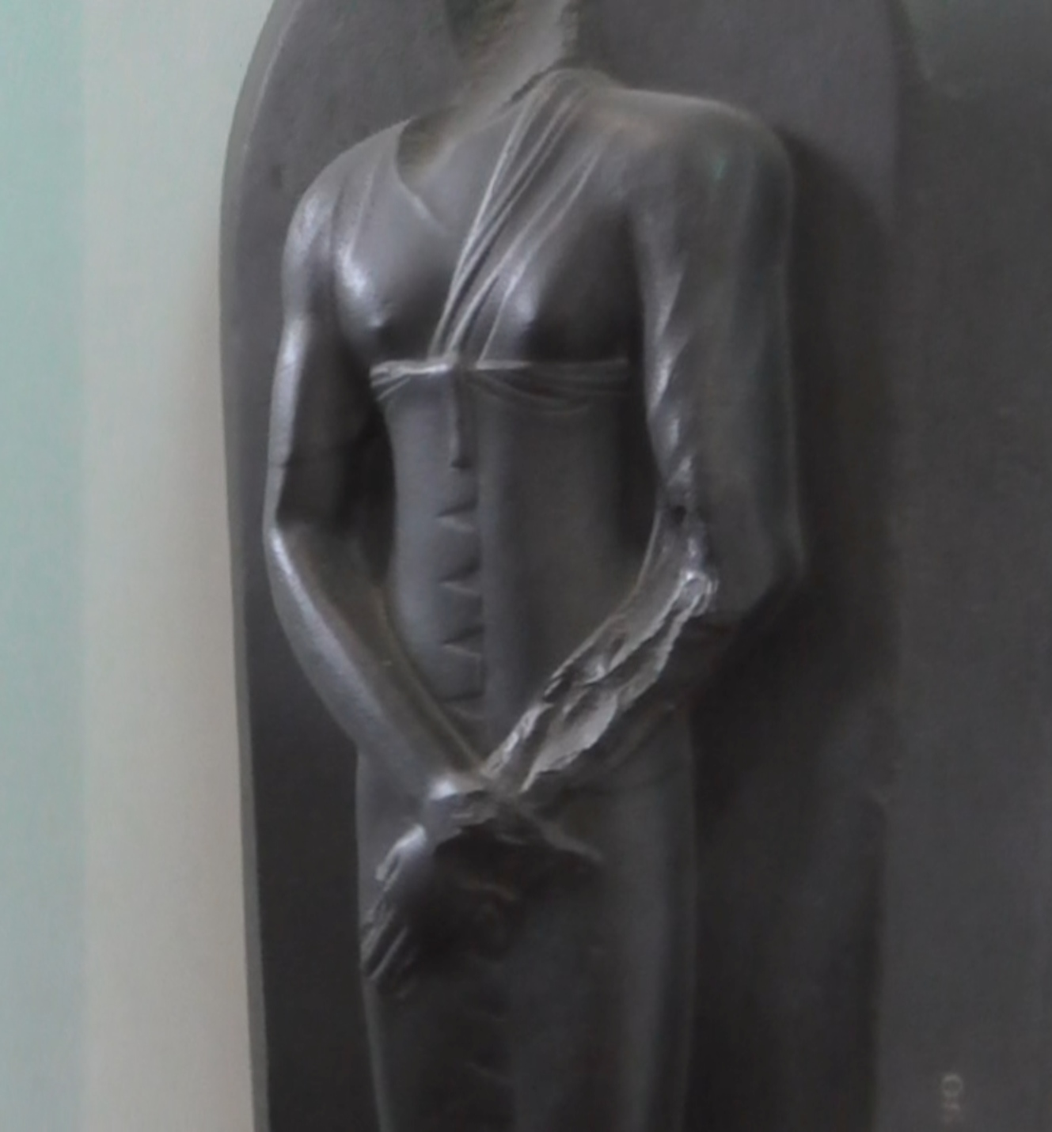

This woman, from the Roman period in Egypt is making the same mime.

And that is just about it. I hope you have enjoyed reading about the dance. Sadly I have never seen it performed. Hopefully, someone will read this and perform it for me. I wish you all the very best. Thank you.

